Project Synopsis on

Online Selling Website on Laravel and HTML Custom



Submitted by:

DZone India IT Solutions.

Engagement Leader: Ravineesh Kumar

+7014319191| +918769567420

sales@dzoneindia.co.in

dzoneindiaitsolutions@gmail.com

Date: 05th july 2021

**What We Deliver**

* Customization
* Quality
* Satisfaction
* Dedication
* Positivity
* Interactivity
* Confidentiality

**SCOPE OF THE PROJECT**

* **Objective**
* **SCOPE**
* **Company Efficiency**
* **System Diagram**
* **Admin (custom)**
* **Customer**

Design Diagram (Customer)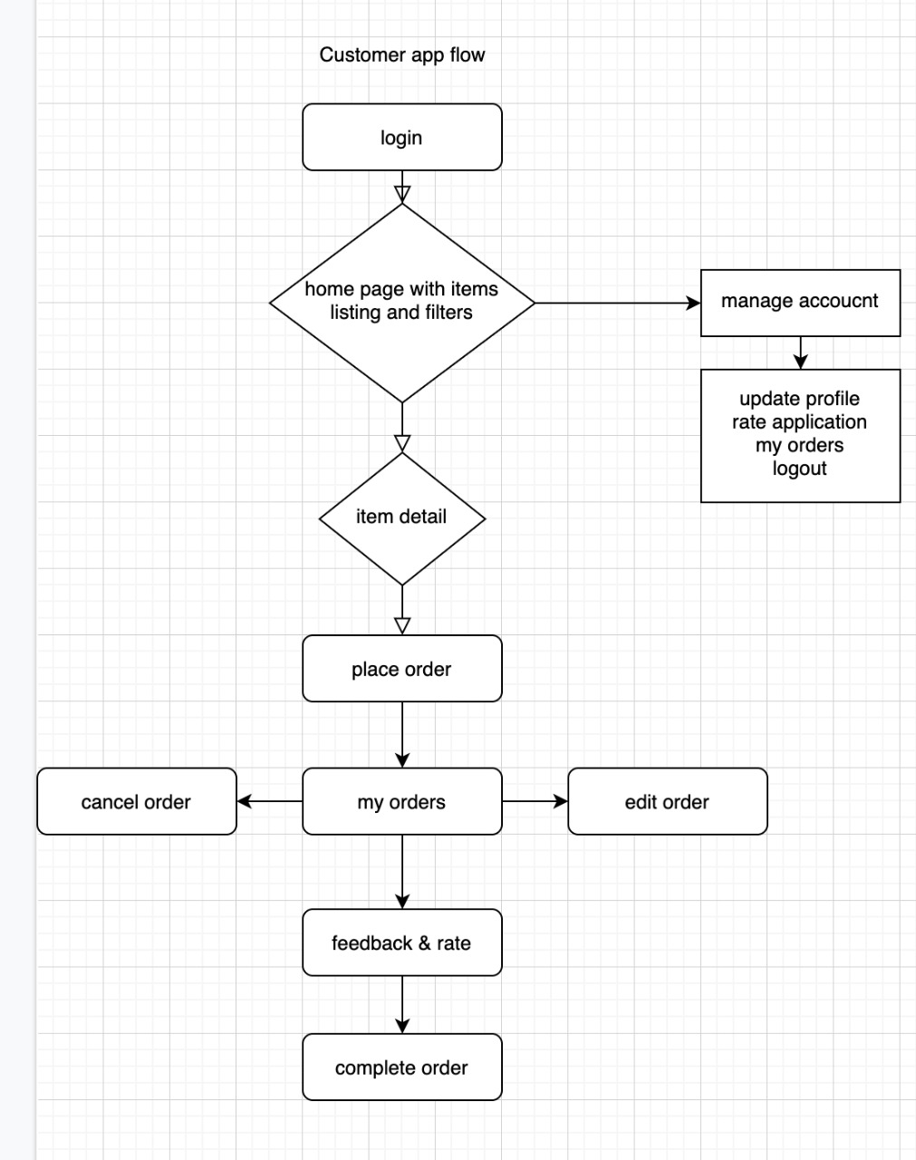

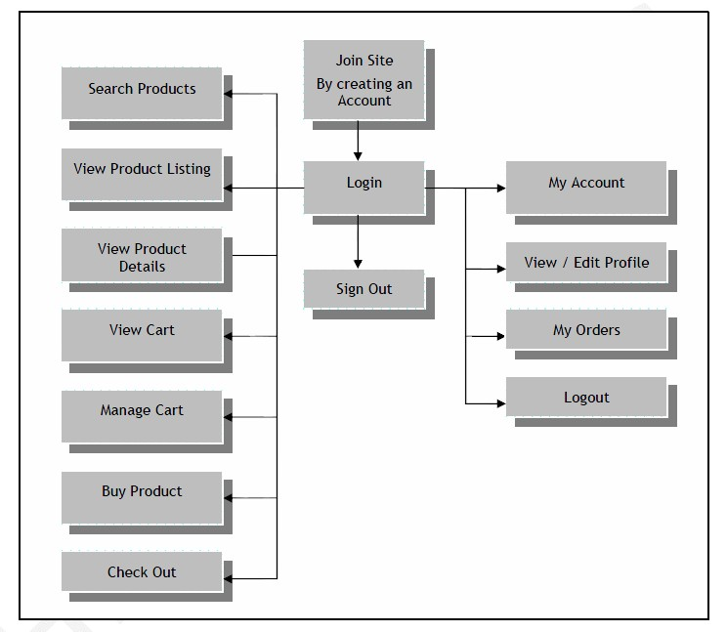

**Admin**

* Login in panel through secure email and password
* Dashboard (Short Summery will be shown)
* **Product Manager**
* Add (name, detail, price, status, image)
* Listing (simple listing and filter)
* Product Category Manager
* Product Sub-Category Manager
* Menu setting
* Add currency wise price
* Multiple Color wise Product upload
* Related Product Setting
* Home page Product Setting (Best Seller, New Arrivals, Trending Product, Look Book, ETC.....)
* Product Discount Manager
* Product Discount Date Wise/Festival wise
* Edit
* Detailed View
* Delete (soft delete)
* Product images
* Rating and reviews
* Price details with choose quantity option
* Product gallery
* Product description Customer reviews
* Unlimited Products listing
* Related Products listing
* Users wish list
* Add products to a single category or multiple categories
* Color Manager
* Size Manager
* Product Type Manager
* Fabric Type Manager
* Pattern Type Manager,
* Material Manager
* Pocket Type Manager
* Brand Type/Name Manager
* Tax Manager
* Change Status (active/inactive)
* Dynamic Attribute Manager
* Add
* Listing
* Edit
* Detailed View
* Delete (soft delete)
* Change Status (active/inactive)
* Color Manager
* Size Manager
* Product Type Manager
* Fabric Type Manager
* Pattern Type Manager,
* Material Manager
* Pocket Type Manager
* Brand Type/Name Manager
* Tax Manager
* Customer Manager
* Listing (simple listing and filter)
* Edit
* Detailed View
* Change Password
* Delete (soft delete)
* Change Status (active/inactive)
* Discount/Coupon Manager
* Add discount codes to categories, brand or products
* Create and manage discount codes
* Coupon for new User
* Create and manage discount codes
* No Of Coupon applied for Existing User
* Set and manage dates code is active
* Single Date wise Coupon
* Multiple date wise coupon and discount
* Set minimum and maximum quantity requirements for discount codes
* Set number of times code can be used before automatically becoming inactive
* Customer Order Manager
* Listing (simple listing and filter)
* Detailed View
* Past order detail view
* Current Order detail view
* Cancelled Order detail view
* Return/Refund Management
* order history management
* Invoice management

* Custom Reports Manager (Exports in Excel)
* Interactive administrative dashboard with charts and statistics
* Revenue Report
* Orders Report
* Products Report
* Categories Report
* Coupons Report
* Taxes Report
* Stock Report
* Customers Report

Reports will be generated and downloaded by excel,(single date wise, multiple date wise, month wise, year wise)

* Page Manager
* Add
* Listing
* Edit
* Detailed View
* Delete (soft delete)
* Change Status (active/inactive)
* Manage Profile
* Edit/Update
* Change Image
* Detailed View
* Change Password
* Feedback Manager
* Listing (simple listing and filter)
* Detailed View
* Delete (soft delete)
* Change Status (active/inactive)
* Log Out

**Customer**

* website View
* Login Screen
* Signup process (approval basis)
* login id/pass through email (admin panel)
* approval request can be approved or rejected by admin
* Gallery image
* My Account complete functionality
* Recently viewed product
* Notification on Gmail and Mobile
* Wallet Amount Redemption (Virtual Money)
* Search items based on (item name, Sku no., Price, latest collection)
* Detailed view of item
* Place order
* My Orders
* Edit order
* Cancel order
* Past orders (complete orders history)
* Order detailed view
* Manage Profile
* Edit/Update
* Change Image
* Detailed View
* Change Password
* Update Address
* Log out
* **Project Exclusions (Things that are not covered in the cost)**
* Hosting/server cost
* SSL
* Domain
* Any third party API/plug-in/extension if used during the development
* **Post Development Support**

We provide 30-day of free support and maintenance for any errors/bugs that might come up during the live user experience. We will try to solve/fix the errors/bugs in minimum turnaround time. The support time starts after final delivery of the project to the client. After the support time period ends, maintenance can be availed on chargeable basis

* Following things will be covered in the maintenance
* Bug/error fixing
* Design modifications/design issues
* Feature extension
* Functionality upgrades
* Server management
* **General Terms**
* The project amount is Exclusive of all taxes
* We work throughout the month except 2nd Saturday and Sundays
* Our team will communicate with you through E-mail or Whats App or Skype or Zoom or any other channel of your choice
* All Payment should be in Favor of Dzone India IT Solutions
* We Accept Payment through NEFT, RTGS, DD, and Cheque Only.

**Website Development Cost**

|  |  |  |  |
| --- | --- | --- | --- |
| S.NO  . | Technology Web (PHP Laravel) | Time Schedule | Amount  Price |
| 1. | Admin Panel : Admin, Customer  Front End Implementation | 30-45 Days |  |
| 2. | Testing and Deployment | 10 Days |  |
| 3. | Total Estimation | 40-60 Days  Demo on Development Server | 1,10,000 |

**Milestone-based payment schedule**

|  |  |  |
| --- | --- | --- |
| **Milestone**  **.** | **Schedule** | **Amount** |
| Milestone 1 | Project kick-off amount so that we can start-off with the work | 30% |
| Milestone 2 | After UI/Front-end design is completed and Admin 50% Completed | 30% |
| Milestone 3 | At the beta-release of the site | 30% |
| Milestone 4 | After the final testing but before site goes live | 10% |

**Resources to be Utilized**

|  |  |
| --- | --- |
| Project Lead | 1 |
| Database Developer | 1 |
| Laravel Developer | 1 |
| HTML Front end Designer | 1 |

**Testing & QA**

|  |  |
| --- | --- |
| Technology Stack Software | Product |
| Database Server | MYSQL |
| Operating system | WINDOW,MAC |
| Development Environment | HTML, PHP LARAVEL FRAMEWORK, JS and jQuery, BOOTSTRAP |

**BROWSER COMPATIBILITY**

|  |
| --- |
| Supported Browser |
| Microsoft Edge Latest Version |
| Firefox Latest Version |
| Google Chrome Latest Version |